A

Project Report on

**WPL 2023 ANALYSIS**

Submitted in partial fulfillment of completion of the course

Advanced Diploma in IT, Networking and Cloud

Submitted by:

**Anoushka Das**

Under Guidance of:

**Arpita Roy (Edunet)**

|  |  |  |
| --- | --- | --- |
|  |  |  |

Year 2022 -2024

Abstract

Acknowledgement

Table of Contents

1. Introduction to Problem

2. Proposed Solution

3. Requirements

3.1 Technology Stack

3.2 Hardware

3.3 Deployment Environment

4. User Requirements

5. Design Documentation

6. Implementation Details

7. Deployment

8. Conclusion

Appendix A Screenshot of Project

References

Abstract

March 2023 saw the first Women’s Indian Premier League (IPL) take place. Since its creation in 2008 the men’s IPL has been a revolutionary competition with the additional benefit of improving domestic Indian cricket. The IPL allowed for city-based franchises to be sold, players were brought at a player auction, international cricket stars were keen to play in India and Indian cricket was able to create its first internationally broadcast sports league.

Central and team sponsorships, broadcast rights, merchandise sales and gate receipts enabled Indian cricket to thrive financially, and the IPL broadcast rights have just sold for over $6.2 billion.

The T20 format, much like in the men’s game, has helped the women’s game to develop. The franchise league of Australia, the Women’s Big Bash League (WBBL) was the first major tournament to drive women’s cricket forward. Since the tournament’s creation in 2015–16 the WBBL has continued to thrive and the 2020-21 competition saw substantial audience figures with average viewing figures reaching over 200,000 per match. This made the WBBL the fourth most-watched domestic league in Australia, behind the BBL, Australian rules football’s AFL and rugby league’s NRL.

The 2021-2022 WBBL tournament saw many world-renowned brands such as Weber, Nike, KFC, CA and Woolworths all partnering with the tournament. Along with the sponsorship of the tournament, broadcast interest has also developed as 16 broadcasters from across the world attained rights to show the tournament.

Acknowledgement

Team ‘Statistical Samurai’ (comprising of 1 member, namely Anoushka Das) is thankful to our teacher,Ms. Arpita Roy for her guidance and supervision which has provided a lot of resources needed in completing our project.

We are also thankful to the efforts put in by our team members and contributions to the preparation of this project.

Table of Contents

Introduction to Problem

Every sporting event today generates a lot of data about the game, which is used to analyze the performance of players, teams, and every event of the game. So the use of data science is in every sport today. I will be analyzing WPL 2023.

The 2023 Women's Premier League, also known as the TATA WPL 2023 for sponsorship reasons, was the inaugural season of the Women's Premier League, a women's franchise Twenty20 cricket league organised by the Board of Control for Cricket in India (BCCI).

Proposed Solution

* Every year BCCI collect more than Rs 2000 Crore revenue from IPL and the tax goes directly to the government’s account.

>Thus this will attract potential investors to invest and sponsor teams, giving rise to a hike in business around the segment.

* The Big Bash League in Australia is exclusively for women.

  >This proves that audience have witnessed such a tournament and is still enjoying the same. Thus, it turned out to be a success.

* Decided that there will be 5 teams of 15-18 players each comprising of approximately 10-12 Indians and 5 overseas players.

> Their game will improve by competing more and more

>They will get their face renowned as their male counterpart.

Requirements

Technology Stack: Python, Numpy, Pandas, seaborn

Software: Jupyter Notebook

Hardware:

Device name DESKTOP-VDV25SG

Processor Intel(R) Core (TM) i7-8700 CPU @ 3.20GHz 3.19 GHz

Installed RAM 16.0 GB (15.8 GB usable)

Device ID F15CC3EA-F8F5-4986-A23B-2D4800C276E9

Product ID 00330-51616-71380-AAOEM

System type 64-bit operating system, x64-based processor

* 1. Deployment Environment:

User Requirements:

* The end users can be any group of people.
* It may be commentators, team advisors, cricket experts, journalists and even investors
* It can also be general public, students or any sports enthusiasts.

5. Design Documentation

6. Implementation Details

* 95% of the runs are scored off bat whereas rest are extras overall. In the first innings, 96% of the runs are scored off bat whereas in the second innings 94% runs comes from bat.
* 42% are balls played are dot balls overall. In the first innings, 41% are dot balls whereas in the second innings 43% are dot balls. At DY Patil Stadium, 45% are dot balls whereas at Brabourne Stadium, 40% are dot balls.
* 17-20% runs are scored in boundaries overall, across innings and at venues.

7. Deployment

8. Conclusion

With the help of analysis we will explore and find out the answers of the questions mentioned below to establish a conclusion.

* Number of matches played
* Impact of toss, batting first and second, venue on match result
* How runs are scored in the season at overall, innings and venue level
* How wickets are taken in the season at overall, innings and venue level
* Innings scores distribution
* Top run scores and wicket takers
* Who won the most number of player of the match awards

Appendix A : Screenshot of Project

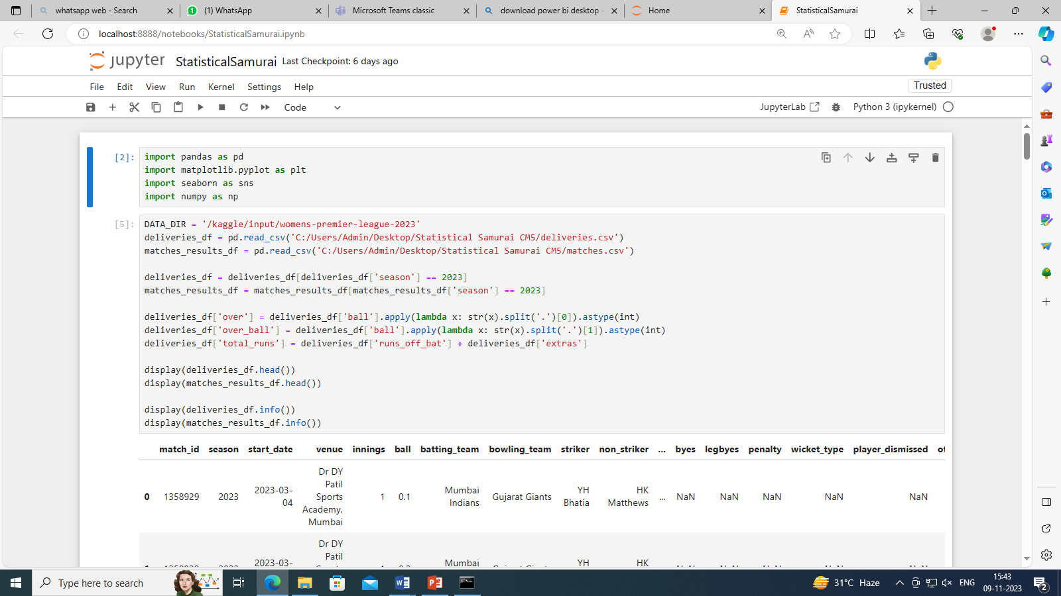

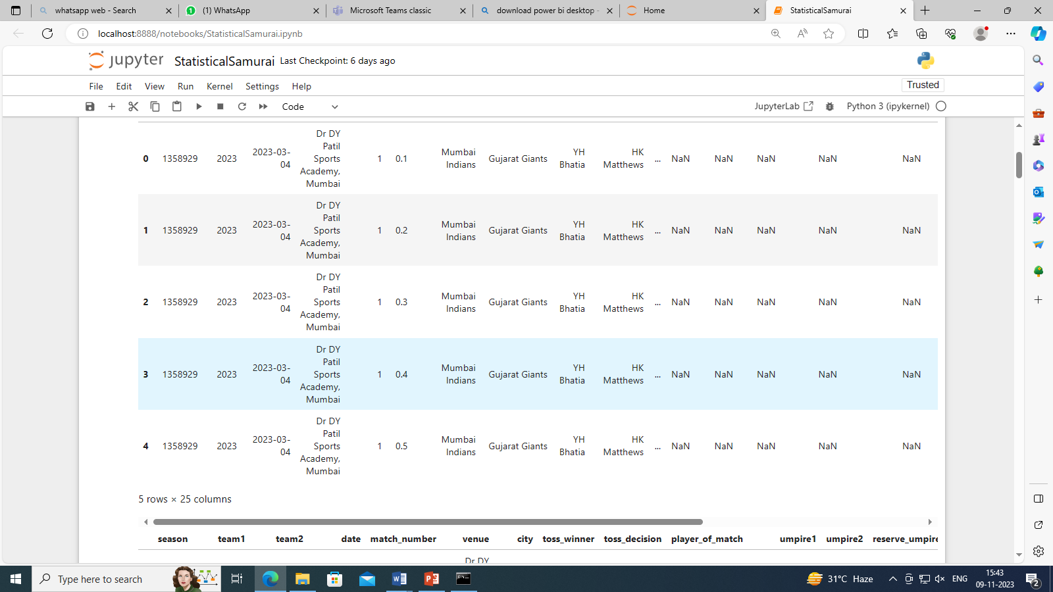

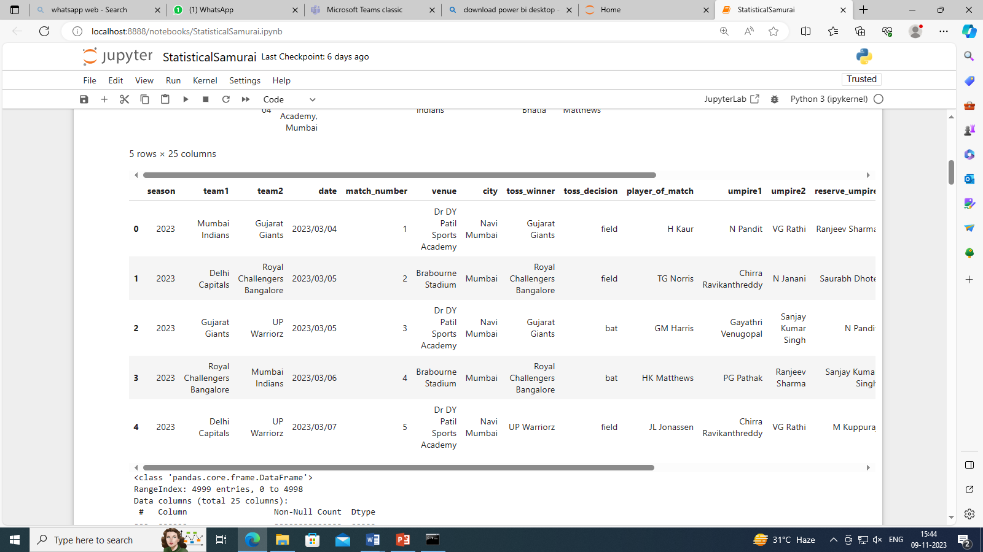

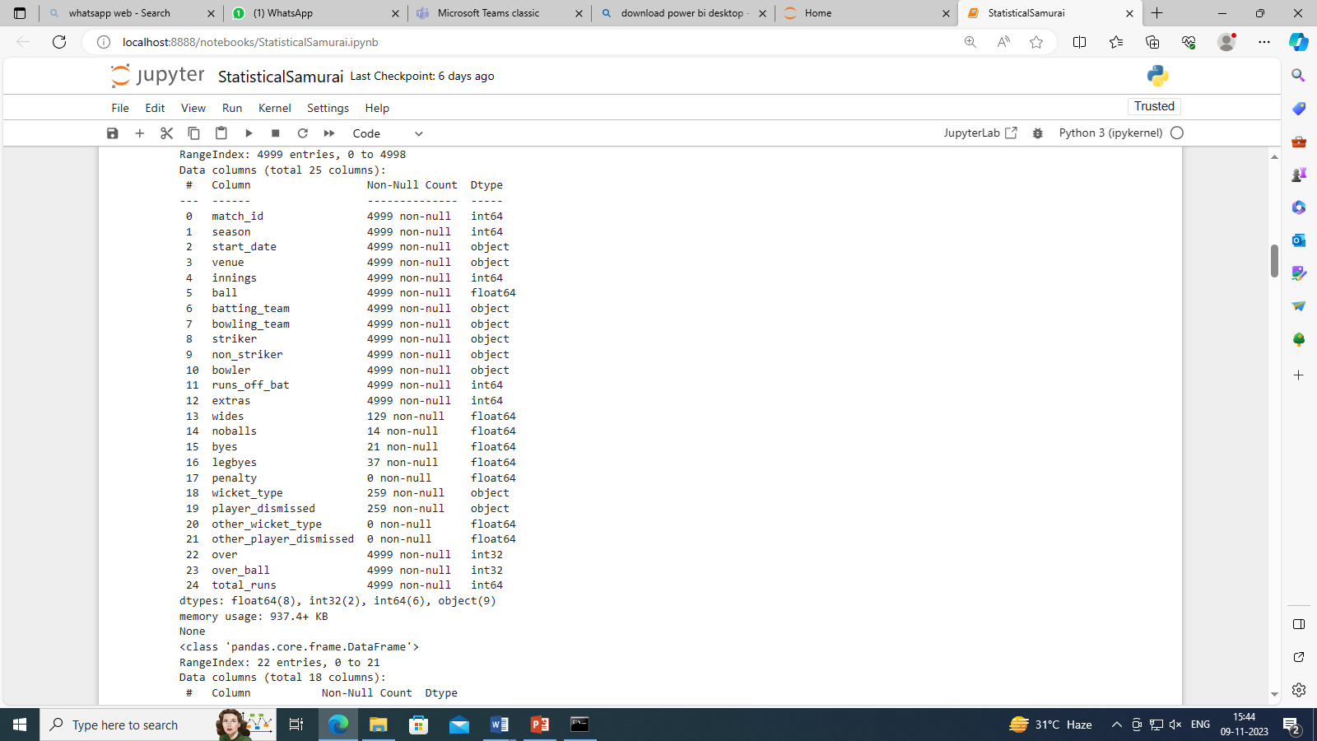

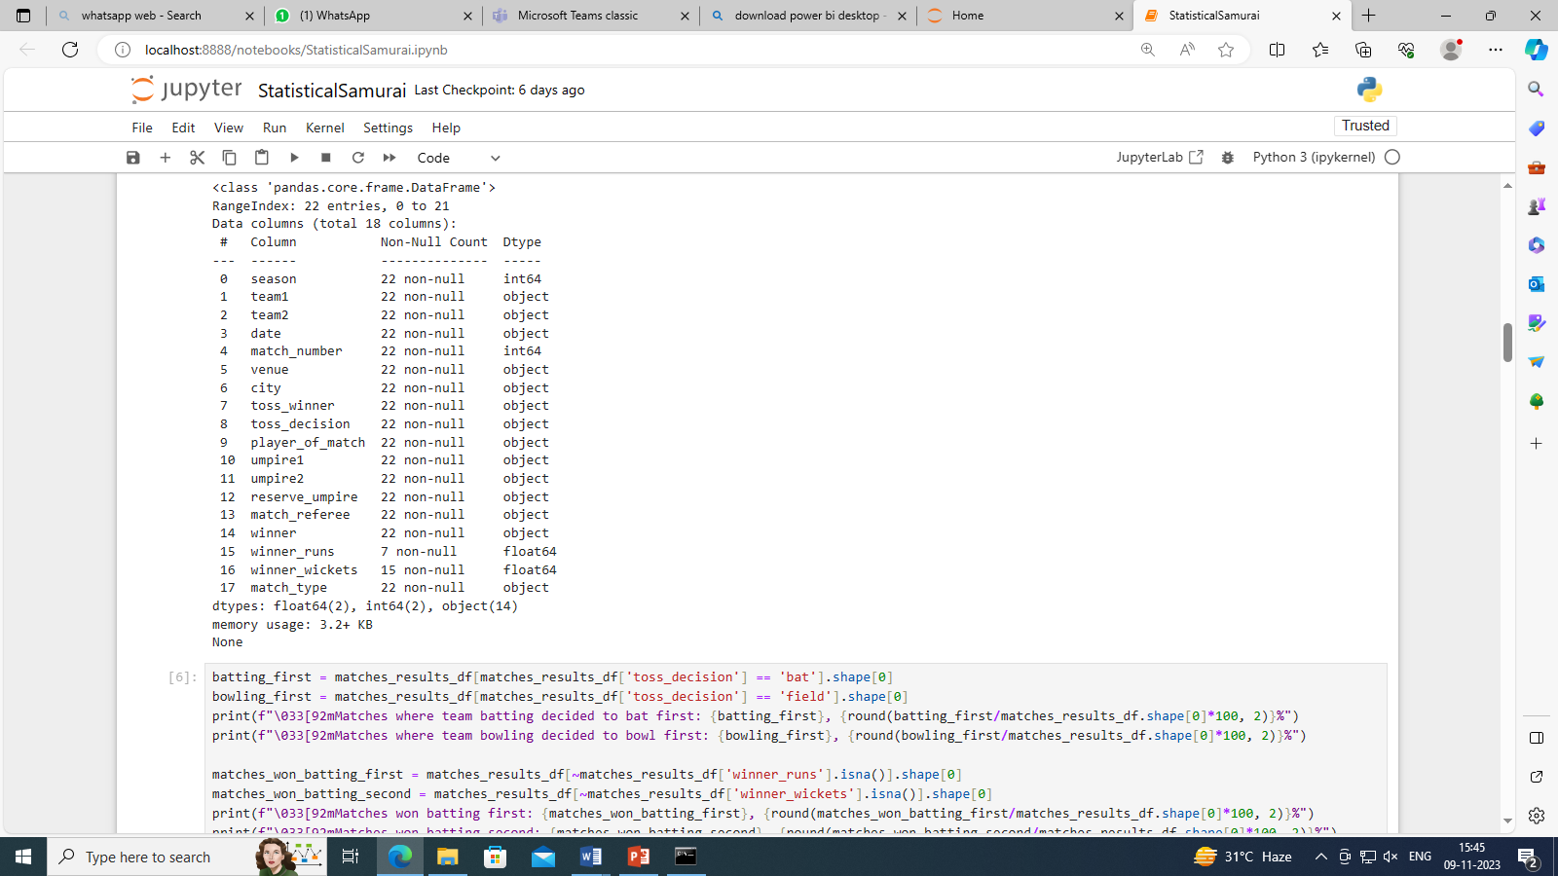

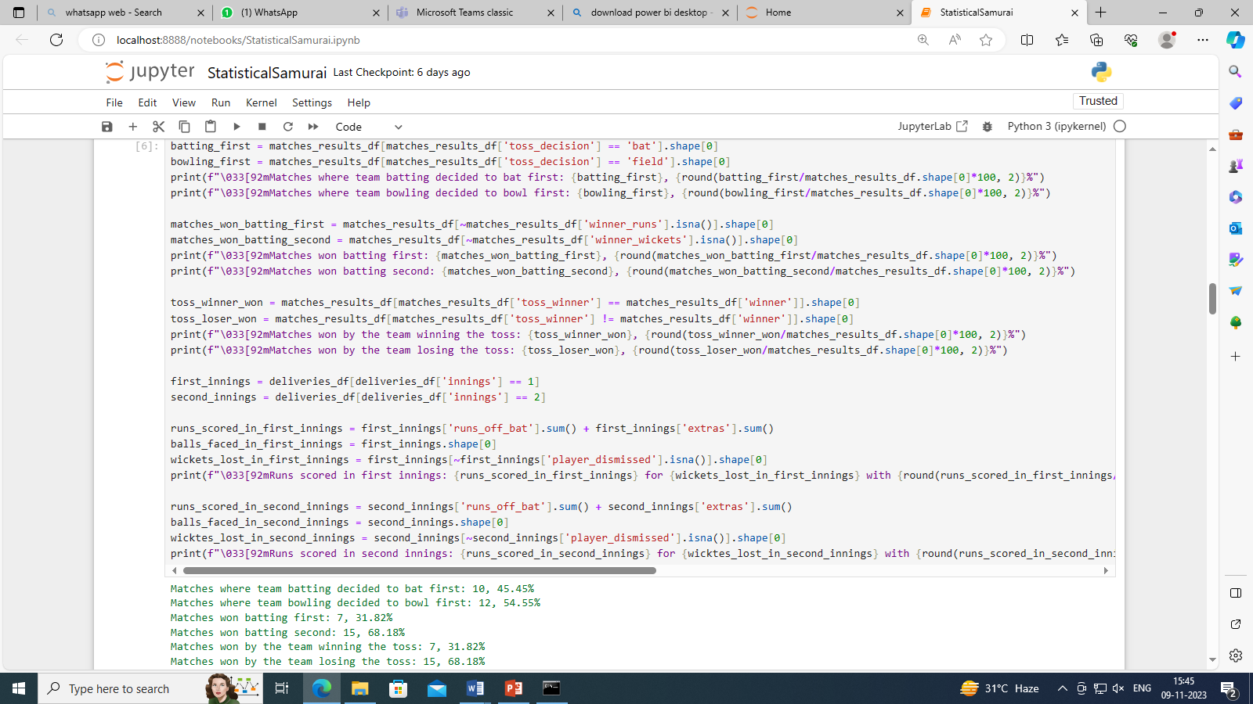

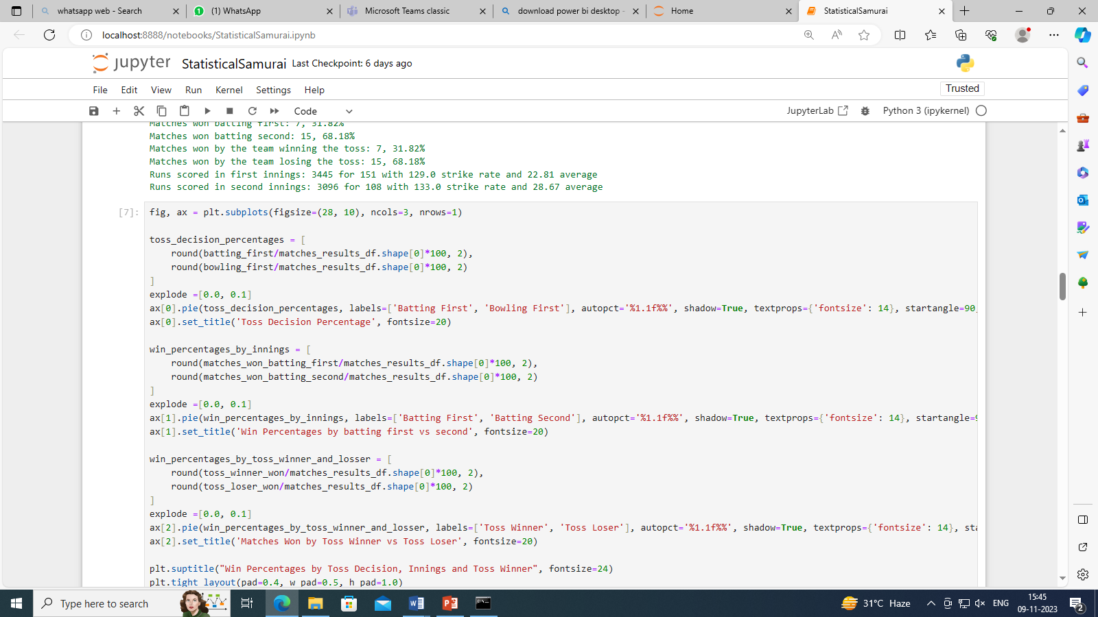

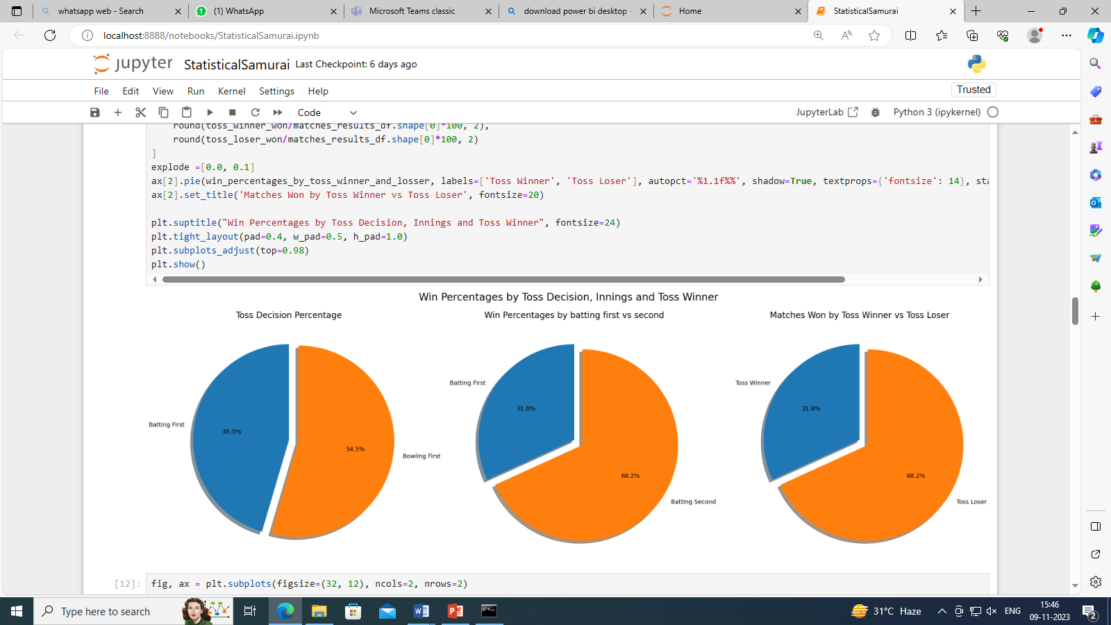

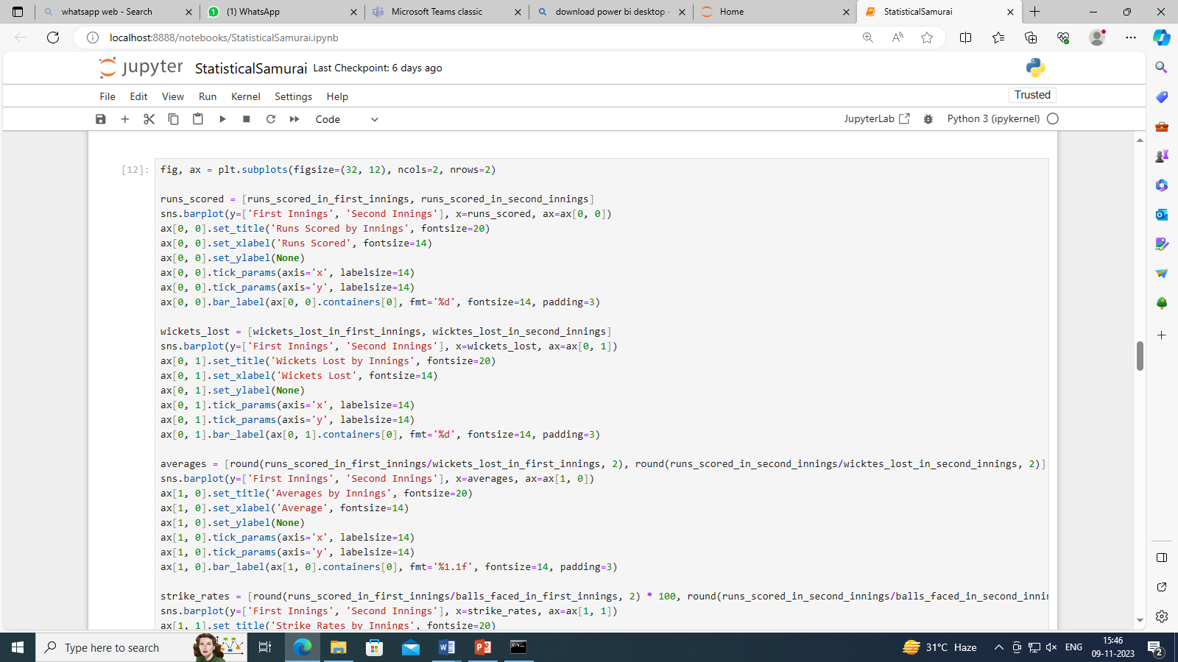

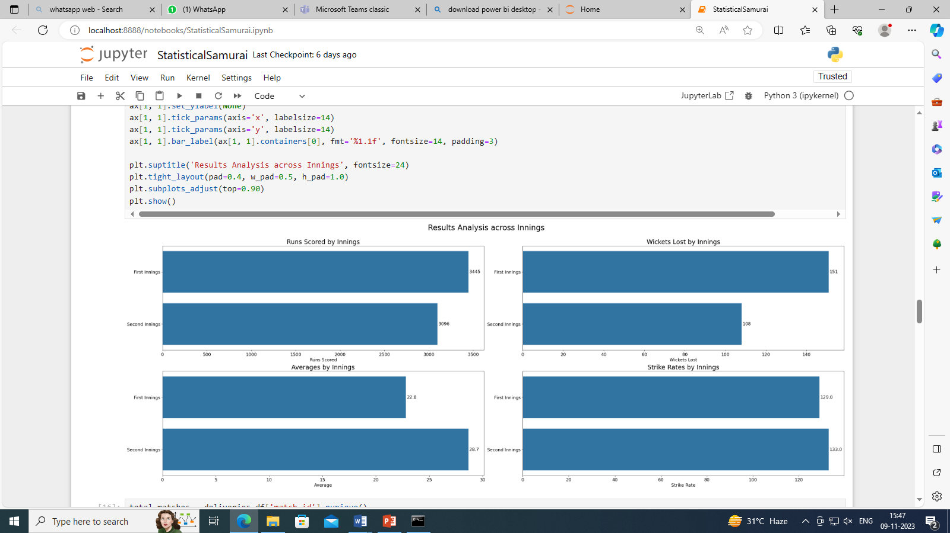

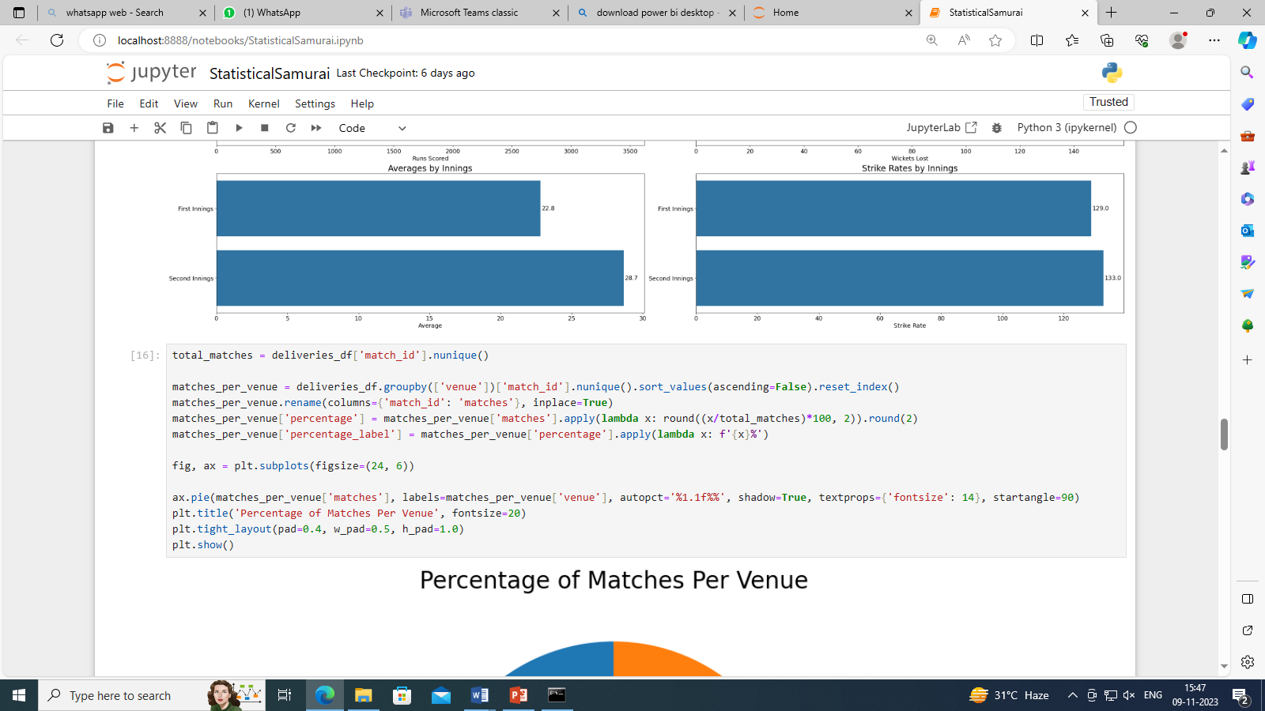

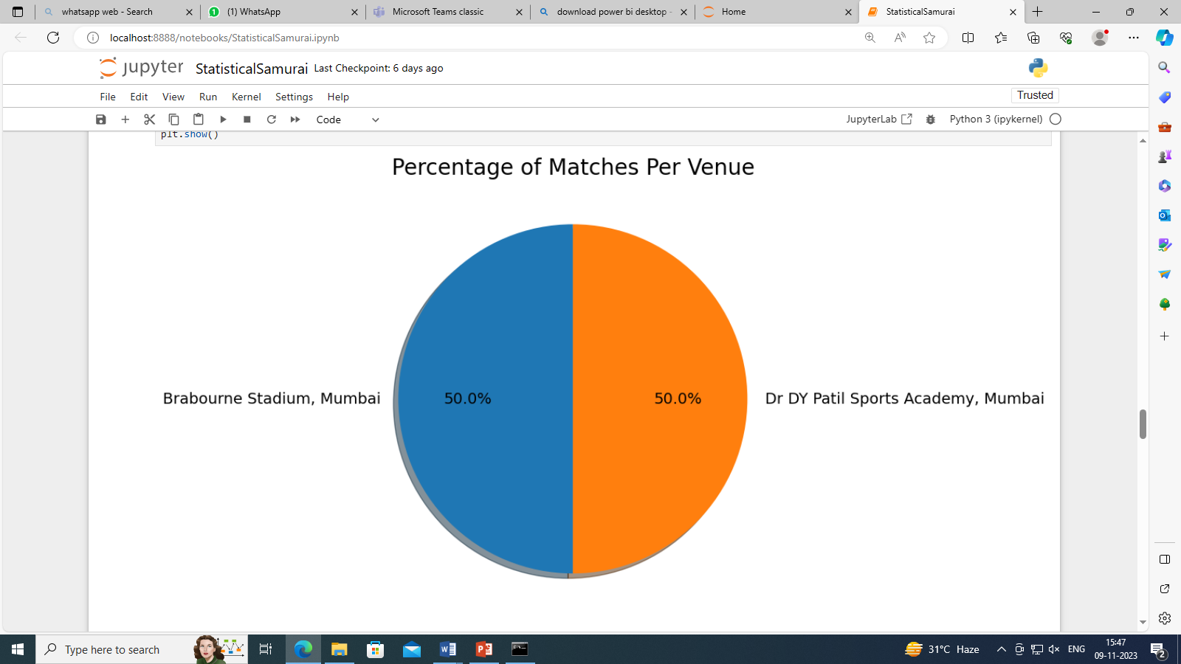

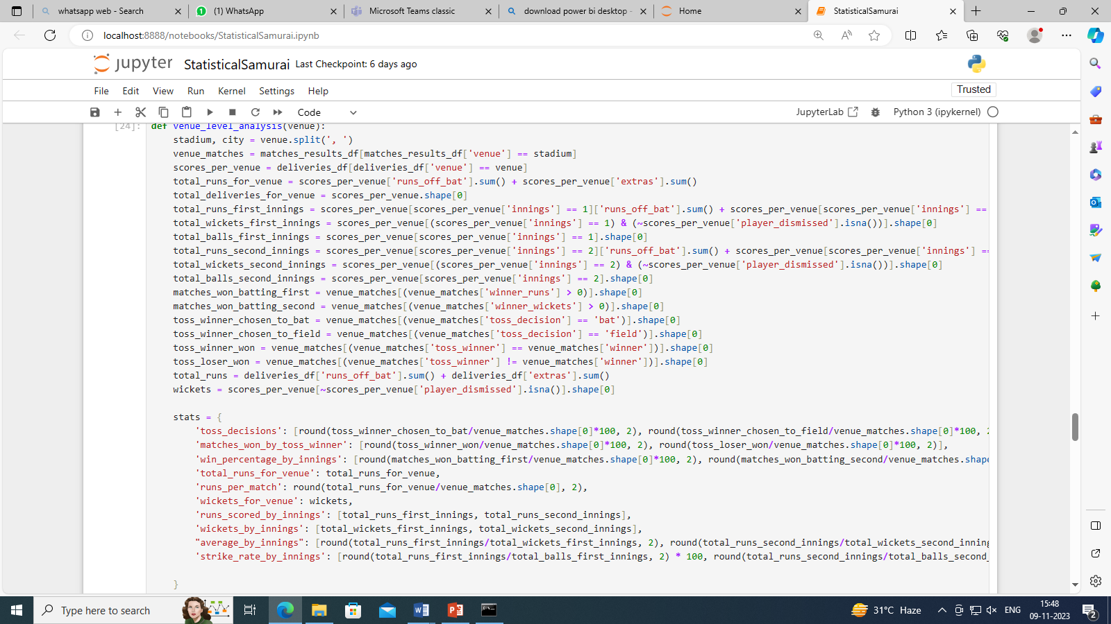

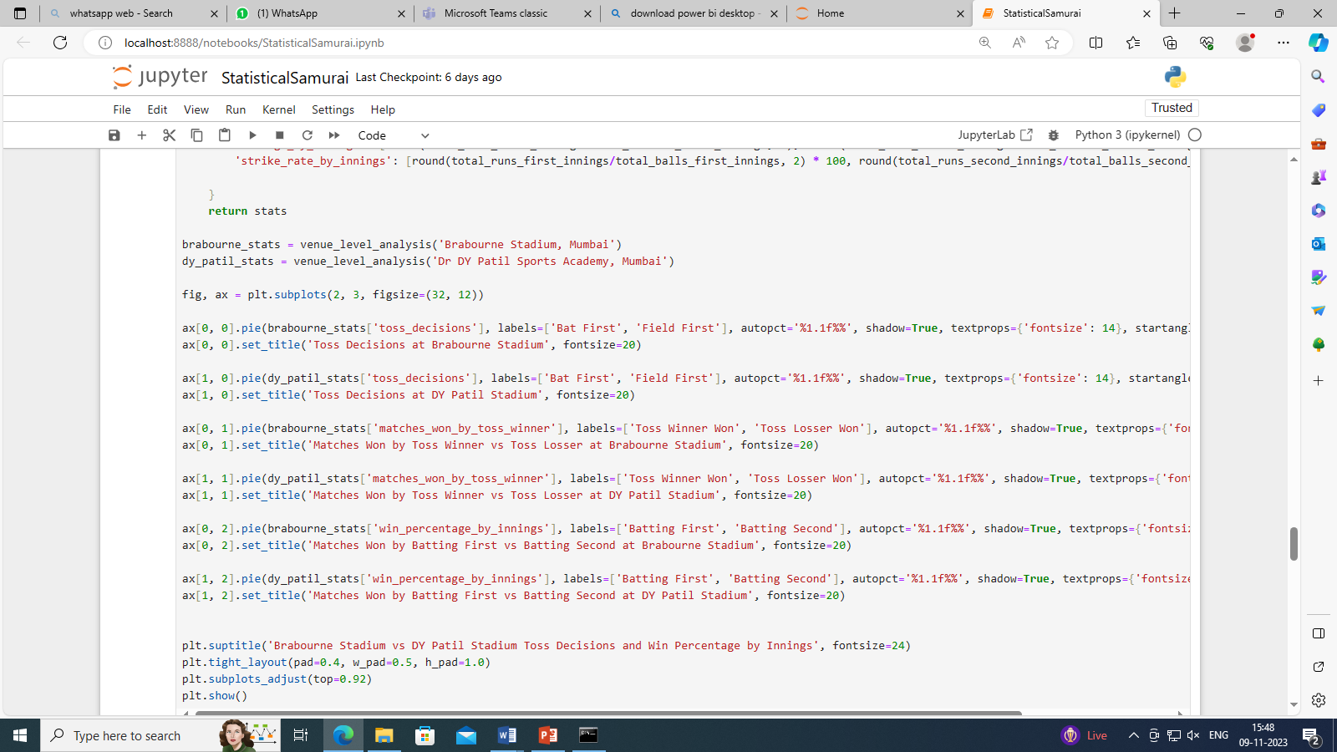

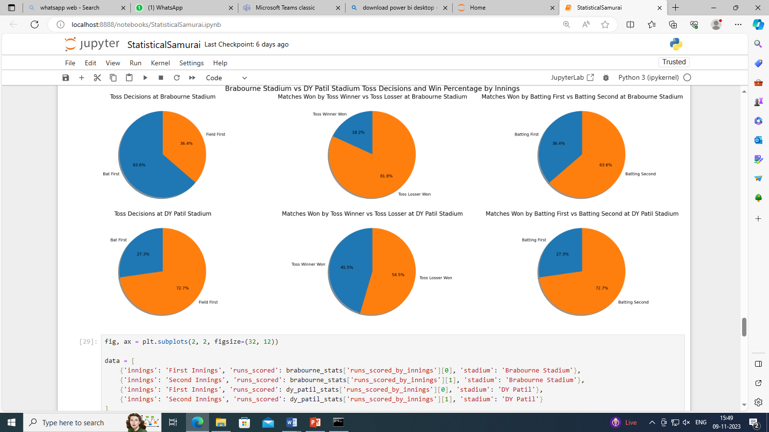

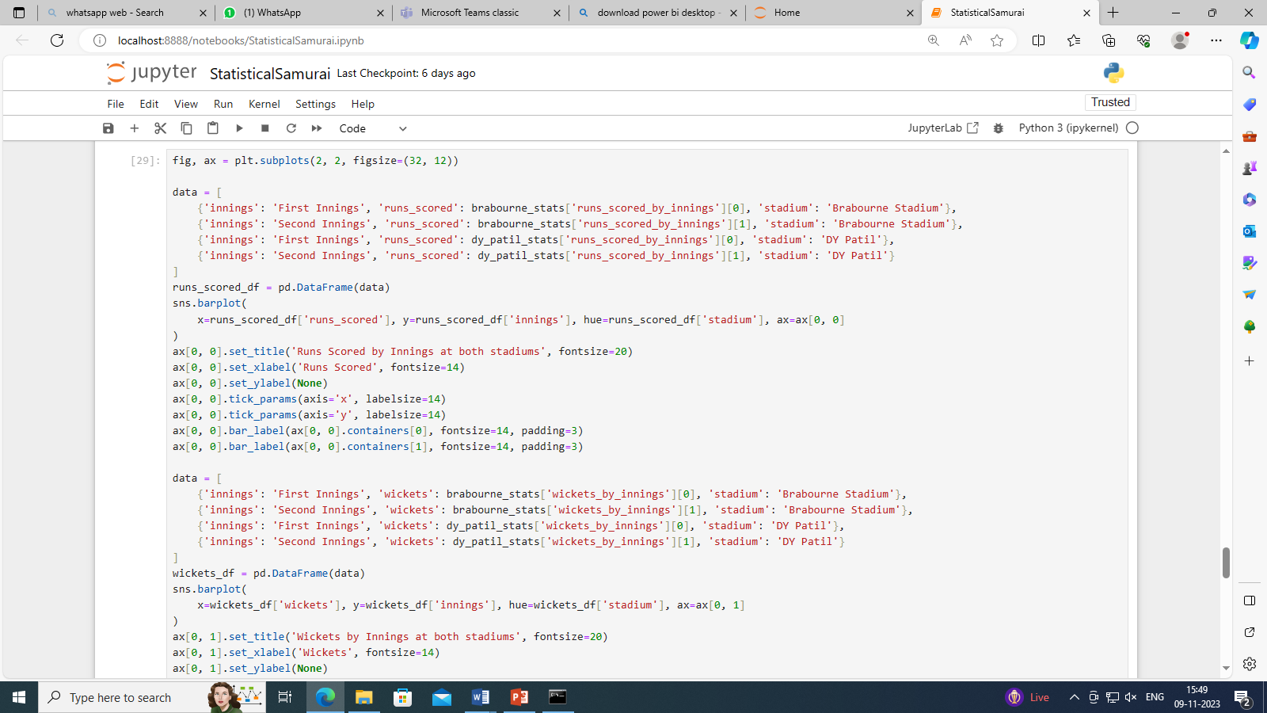

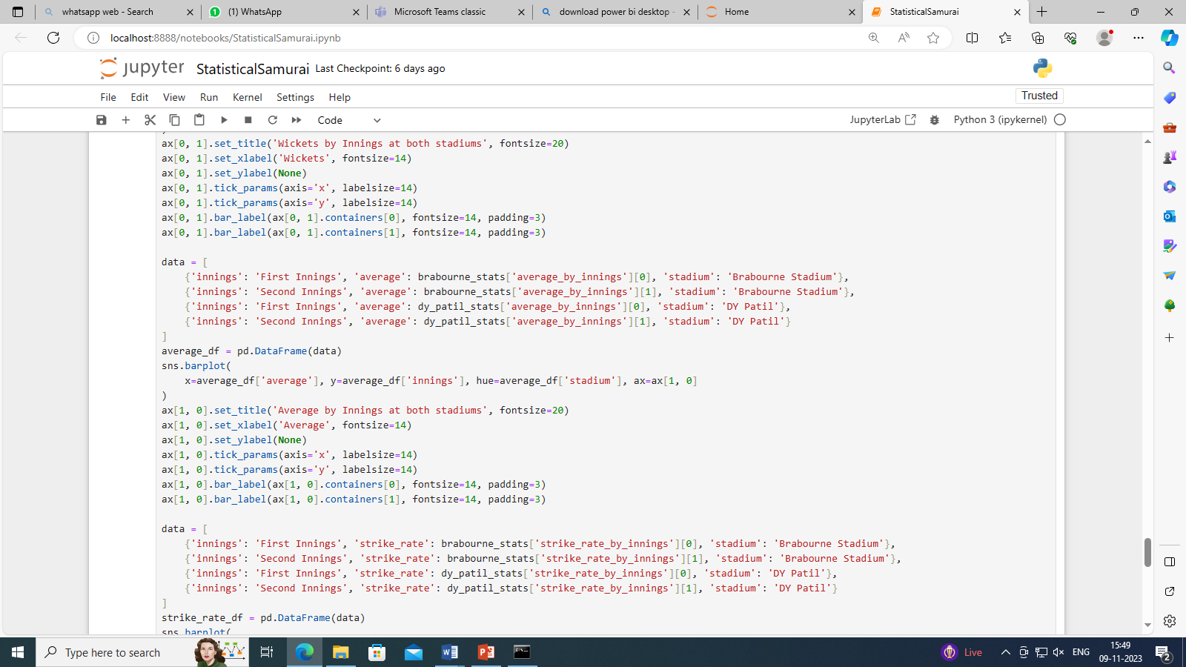

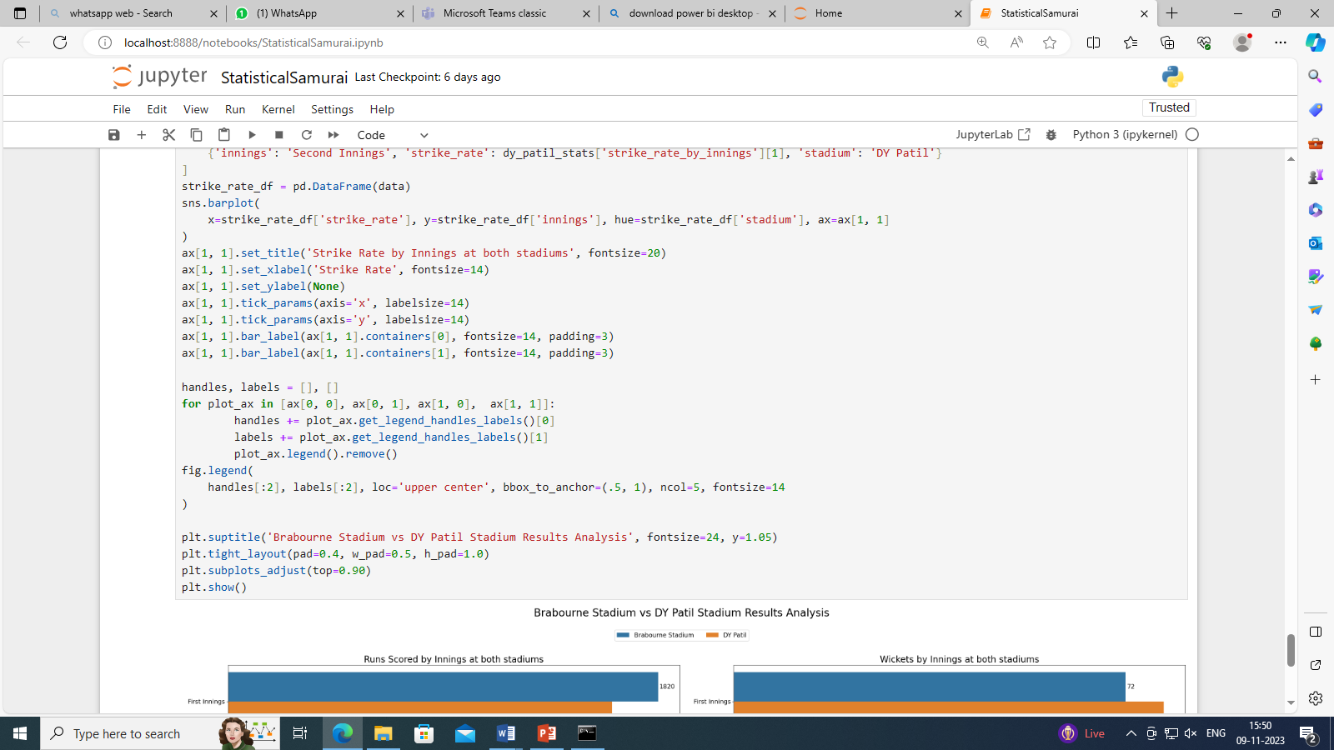

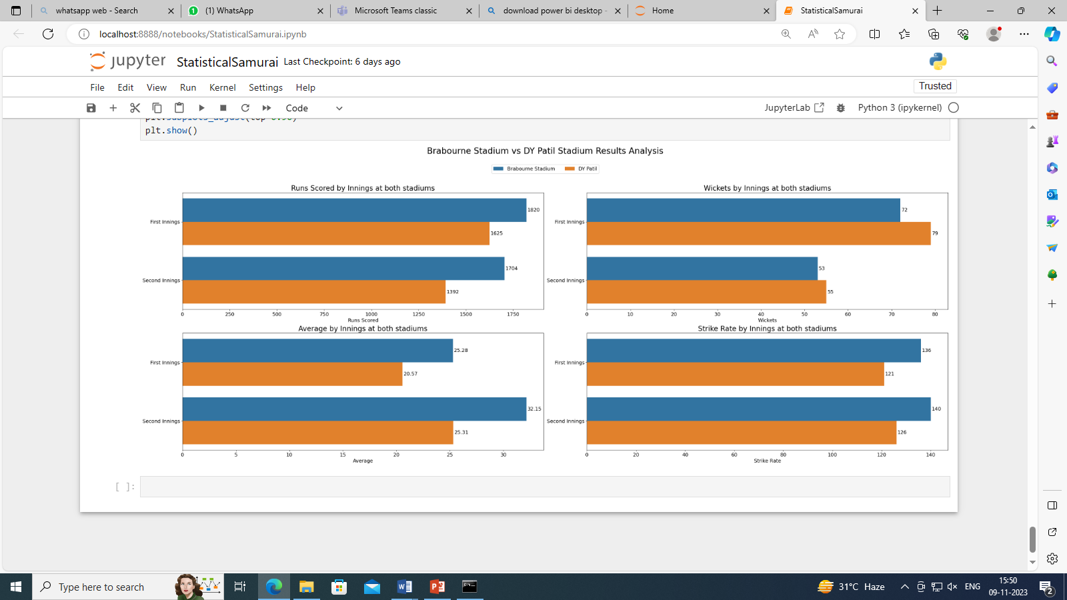

References:

[www.google.com](http://www.google.com)

[www.kaggle.com](http://www.kaggle.com)